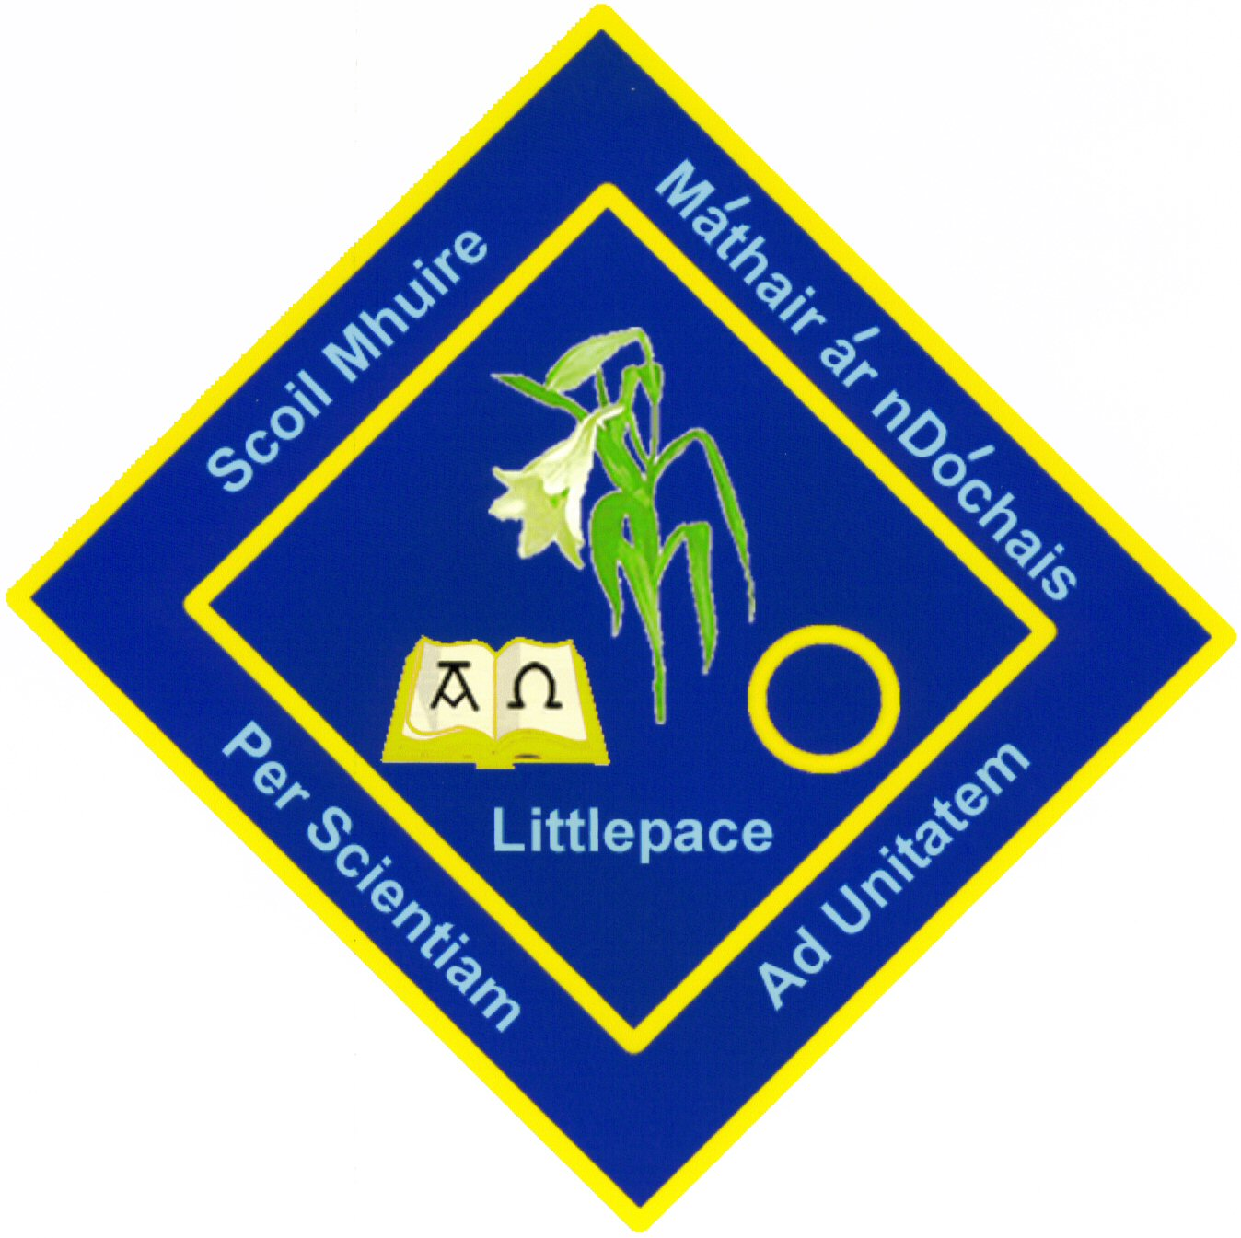
Mary, Mother of Hope S.N.S,
Littlepace, Dublin 15.

Third Class Book List 2019/20

These are the books the children will be using throughout the year. Parents are asked to purchase all books at the beginning of the year. They will be stored in school until they are needed.
It is essential that all books are covered and your child’s name clearly labelled on the front cover of the books.

Gaeilge: Ceartlitriú 3 (CJ Fallon)
English: Go with the Flow Handwriting Book E (CJ Fallon)
Spellbound 3 (CJ Fallon)
Chambers Primary Dictionary (Carroll ED Ltd.) (Especially written for pupil 7+)
(Dictionary to be kept from 3rd – 6th)
Mathematics: Master your Maths 3 (CJ Fallon)

SESE: New Irish Primary Atlas & Free Atlas Hunt Activity Book (Folens)
(This atlas will be kept and used from 3rd – 6th)

If your child is not in the School’s Book Rental Scheme you will need to buy the following books.
- Planet Maths Textbook 3rd class (Folens)
- Reading Zone 3rd class: The Talking Horse (Folens)
- Bun go Barr 3 (CJ Fallon)
- Grow in Love 5 (3rd Class) (Veritas)
- Mary Mother of Hope S.N.S Homework Journal (available from school in September. Each child must use this journal Cost €5)
You will also be required to pay €5 rental for the History and Geography books if you are not in the main Book Rental Scheme.

Your child will also need

- 10 x Writing copies (88 page with margin at side)
- 2x Maths copies (7mm squared, 88 pages)
- 2 x A5 Hardback Copies
- 1 Hard Back Ring-Binder Folder with Plastic Pockets and Dividers

Pencil Case Contents
Your child must come to school each day with a pencil case to include the following:

- 4 x HB pencils, 1 x pencil sharpener,
2 x erasers
- 2 x red pen, 1 Ruler (30cm),
- Each child must have his or her own set of colouring pencils/crayons.
- 2 black whiteboard markers
(Available for €1 each in the school shop from September)
- 2 x highlighters

.
Hand Towel
Each child is required to bring a small hand towel (eg: facecloth) to school for bathroom use to dry hands. This should be changed on a regular basis.

* Please label all items including stationery and all items of clothing*(school uniform)

School Contribution
€70 to cover the cost of parallel readers, photocopying, art materials, standardised tests, report cards and class materials. (The charge for a second family member in either the Junior or Senior school is €40). A maximum of €110 per family should be paid.)
Book Sale by Book Haven Roselawn Shopping Centre, Dublin 15
All new books can be bought at the school on Monday 1O^{th} June from 9.00am-2.00pm in the Junior School hall.

